**Scripting Task**

1. Create a shell script to print the HTTP error code of guvi.in & print, the success/failure message based on the error code response

#!/bin/bash

URL="https://www.guvi.in"

HTTP_STATUS=$(curl -s -o /dev/null -w "%{http_code}" $URL)

echo "HTTP Status Code: "$HTTP_STATUS

if [ $HTTP_STATUS -eq 200 ]; then

echo "Success - The website is accessible."

else

echo "Failure - The website returned an error"

fi

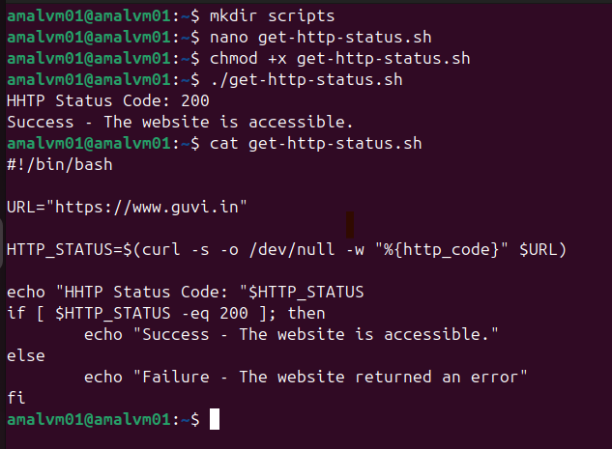

2. Given a file, replace all occurrence of the word "give" with "learning" from 5th line till the end in only those lines that contain the word "welcome"

#!/bin/bash

input_file="./demo.txt"

temp_file="./temp_file.txt"

awk 'NR < 5 {print; next}

/welcome/ {gsub(/give/, "learning"); print}

!/welcome/ {print}' "$input_file" > "$temp_file"

mv "$temp_file" "$input_file"

